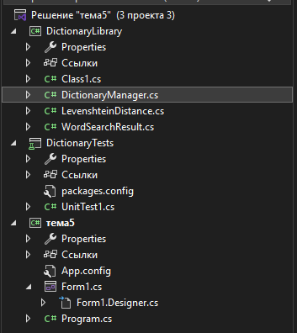
Итоговая структура
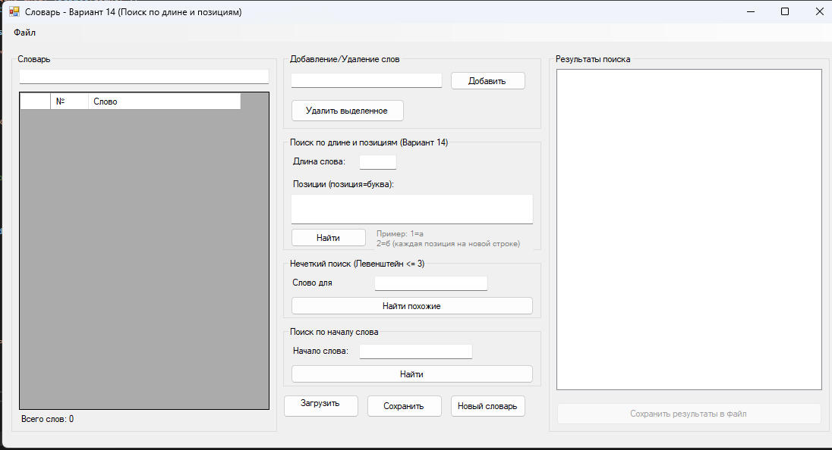
Рабочая форма
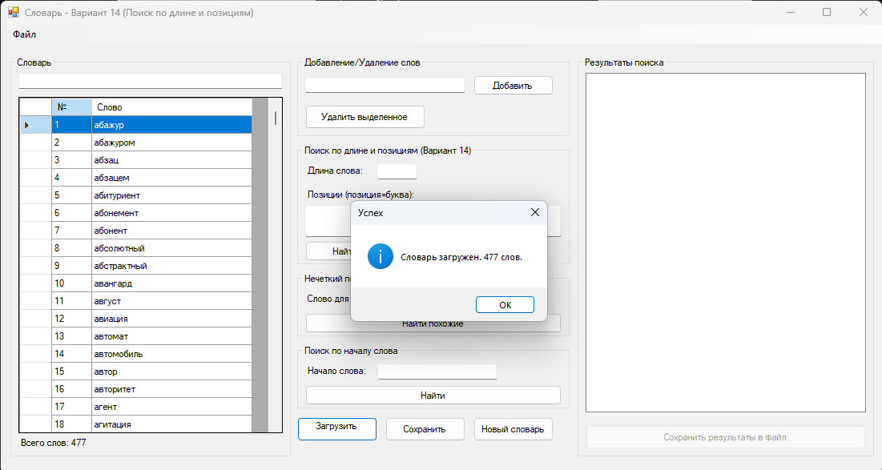
Успешная загрузка (файл с словами в папке)
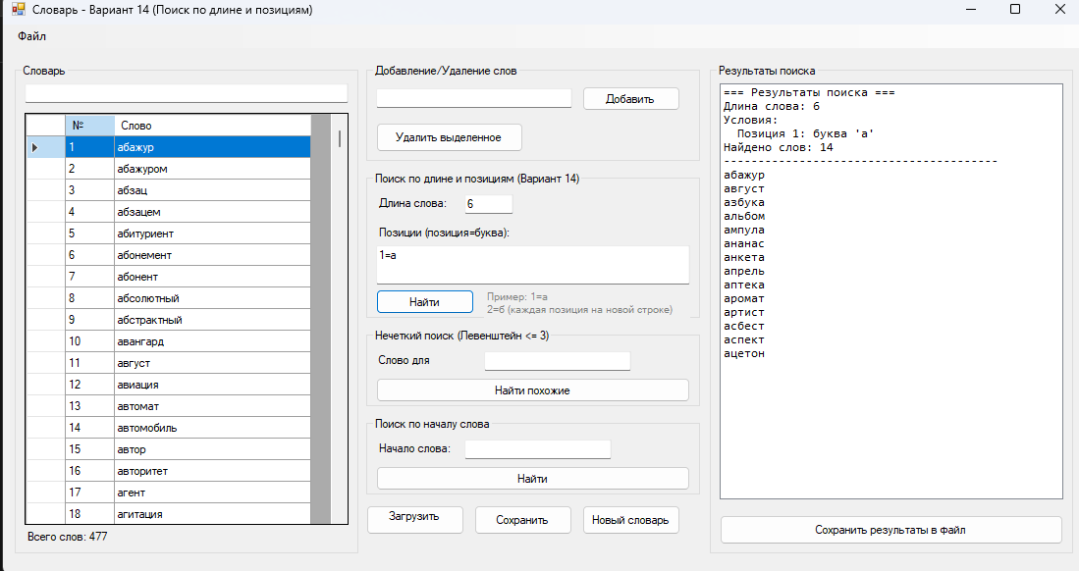
Длина слова 6, первая буква а
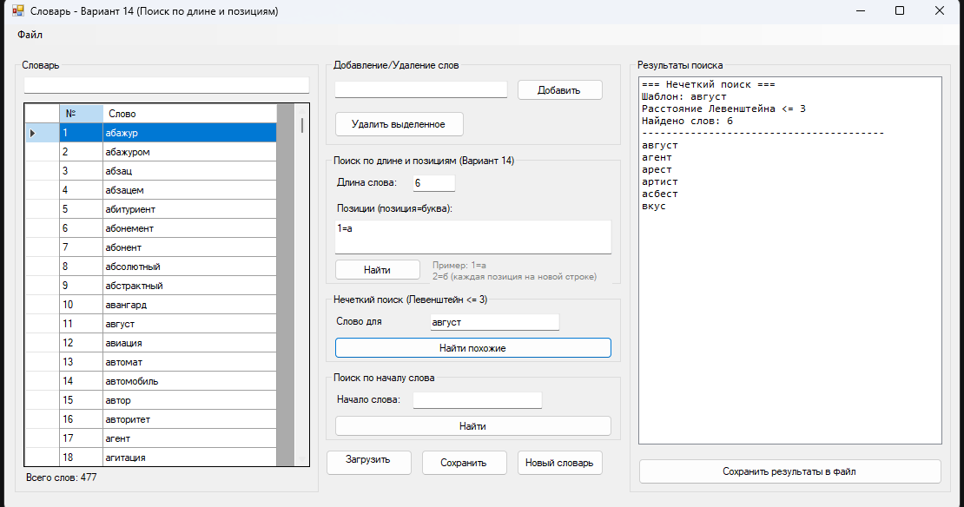
Похожие слова
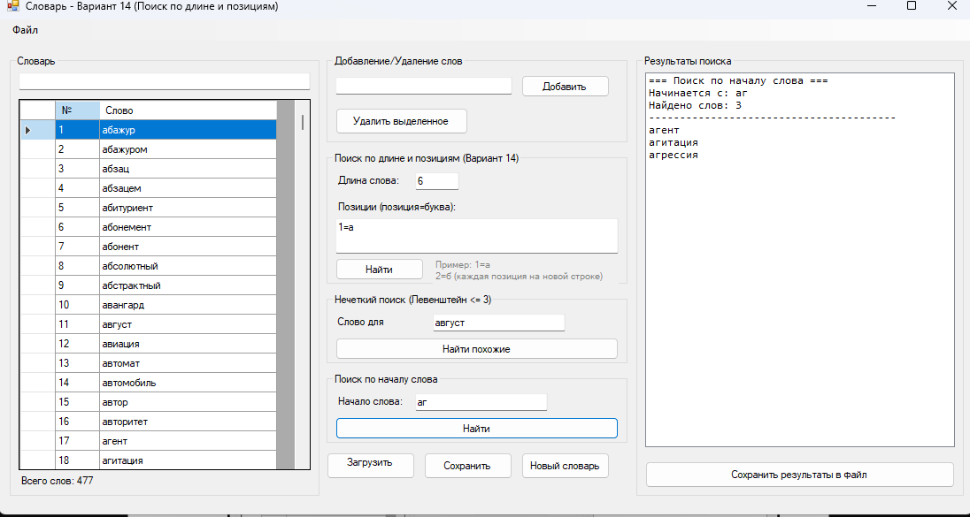
Начало слова аг
Код DicronaryManager.cs:
using System;
using System.Collections.Generic;
using System.IO;
using System.Text;
using System.Linq;

namespace DictionaryLibrary
{
public class DictionaryManager
{
private List<string> dictionary;
private string currentFilePath;
private bool isModified;
private string dictionaryName;

public DictionaryManager()
{
dictionary = new List<string>();
currentFilePath = "";
isModified = false;
dictionaryName = "Новый словарь";
}

public DictionaryManager(string filePath)
{
dictionary = new List<string>();
currentFilePath = filePath;
dictionaryName = Path.GetFileNameWithoutExtension(filePath);
LoadDictionary(filePath);
}

public int Count
{
get { return dictionary.Count; }
}

public bool IsModified
{
get { return isModified; }
}

public string DictionaryName
{
get { return dictionaryName; }
set { dictionaryName = value; }
}

public string CurrentFilePath
{
get { return currentFilePath; }
}

public List<string> GetAllWords()
{
return new List<string>(dictionary);
}

public List<string> GetWordsStartingWith(string prefix)
{
if (string.IsNullOrEmpty(prefix))
return new List<string>(dictionary);

return dictionary.Where(w => w.StartsWith(prefix, StringComparison.OrdinalIgnoreCase)).ToList();
}

/// <summary>
/// Загрузка словаря из файла с автоматическим определением кодировки
/// </summary>
public void LoadDictionary(string filePath)
{
try
{
dictionary.Clear();

Encoding encoding = GetFileEncoding(filePath);

using (StreamReader reader = new StreamReader(filePath, encoding))
{
string line;
while ((line = reader.ReadLine()) != null)
{
line = line.Trim().ToLower();
if (!string.IsNullOrEmpty(line) && !dictionary.Contains(line))
{
dictionary.Add(line);
}
}
}

dictionary.Sort();
currentFilePath = filePath;
dictionaryName = Path.GetFileNameWithoutExtension(filePath);
isModified = false;
}
catch (Exception ex)
{
throw new Exception($"Ошибка загрузки словаря: {ex.Message}");
}
}

/// <summary>
/// Определение кодировки файла
/// </summary>
private Encoding GetFileEncoding(string filePath)
{
// Сначала пробуем UTF-8 с BOM
byte[] bom = new byte[4];
using (FileStream fs = new FileStream(filePath, FileMode.Open, FileAccess.Read))
{
fs.Read(bom, 0, 4);
}

// Проверка BOM
if (bom[0] == 0xEF && bom[1] == 0xBB && bom[2] == 0xBF)
return Encoding.UTF8;

if (bom[0] == 0xFF && bom[1] == 0xFE)
return Encoding.Unicode;

if (bom[0] == 0xFE && bom[1] == 0xFF)
return Encoding.BigEndianUnicode;

// Для русского языка чаще всего используется Windows-1251
try
{
string content1251;
using (StreamReader reader = new StreamReader(filePath, Encoding.GetEncoding(1251)))
{
content1251 = reader.ReadToEnd();
}

// Проверяем наличие русских букв
if (System.Text.RegularExpressions.Regex.IsMatch(content1251, @"[а-яА-Я]"))
{
return Encoding.GetEncoding(1251);
}
}
catch { }

// По умолчанию UTF-8
return Encoding.UTF8;
}

/// <summary>
/// Сохранение словаря в файл в UTF-8
/// </summary>
public void SaveDictionary(string filePath)
{
try
{
using (StreamWriter writer = new StreamWriter(filePath, false, Encoding.UTF8))
{
foreach (string word in dictionary)
{
writer.WriteLine(word);
}
}

currentFilePath = filePath;
dictionaryName = Path.GetFileNameWithoutExtension(filePath);
isModified = false;
}
catch (Exception ex)
{
throw new Exception($"Ошибка сохранения словаря: {ex.Message}");
}
}

/// <summary>
/// Добавление слова в словарь
/// </summary>
public bool AddWord(string word)
{
if (string.IsNullOrWhiteSpace(word))
return false;

string lowerWord = word.Trim().ToLower();

if (dictionary.Contains(lowerWord))
return false;

dictionary.Add(lowerWord);
dictionary.Sort();
isModified = true;
return true;
}

/// <summary>
/// Удаление слова из словаря
/// </summary>
public bool RemoveWord(string word)
{
string lowerWord = word.Trim().ToLower();

if (dictionary.Remove(lowerWord))
{
isModified = true;
return true;
}

return false;
}

/// <summary>
/// Поиск слов по длине и позициям букв (Вариант 14)
/// </summary>
public WordSearchResult FindByLengthAndPositions(int length, Dictionary<int, char> positions)
{
WordSearchResult result = new WordSearchResult();

string pattern = $"Длина: {length}, Позиции: ";
foreach (var pos in positions)
{
pattern += $"{pos.Key + 1}={pos.Value} ";
}
result.SearchPattern = pattern;

foreach (string word in dictionary)
{
if (word.Length != length)
continue;

bool matches = true;

foreach (var pos in positions)
{
int position = pos.Key;
char expectedChar = pos.Value;

if (position >= word.Length || word[position] != expectedChar)
{
matches = false;
break;
}
}

if (matches)
{
result.AddWord(word);
}
}

result.Sort();
return result;
}

/// <summary>
/// Поиск слов по длине и позициям с несколькими вариантами букв
/// </summary>
public WordSearchResult FindByLengthAndMultiplePositions(int length, Dictionary<int, List<char>> positions)
{
WordSearchResult result = new WordSearchResult();

foreach (string word in dictionary)
{
if (word.Length != length)
continue;

bool matches = true;

foreach (var pos in positions)
{
int position = pos.Key;
List<char> allowedChars = pos.Value;

if (position >= word.Length || !allowedChars.Contains(word[position]))
{
matches = false;
break;
}
}

if (matches)
{
result.AddWord(word);
}
}

result.Sort();
return result;
}

/// <summary>
/// Нечеткий поиск слов с расстоянием Левенштейна не более 3
/// </summary>
public WordSearchResult FuzzySearch(string pattern, int maxDistance = 3)
{
WordSearchResult result = new WordSearchResult(pattern);

foreach (string word in dictionary)
{
if (LevenshteinDistance.IsWithinDistance(word, pattern, maxDistance))
{
result.AddWord(word);
}
}

result.Sort();
return result;
}

/// <summary>
/// Поиск по началу слова
/// </summary>
public WordSearchResult SearchByPrefix(string prefix)
{
WordSearchResult result = new WordSearchResult($"Начинается с: {prefix}");

foreach (string word in dictionary)
{
if (word.StartsWith(prefix, StringComparison.OrdinalIgnoreCase))
{
result.AddWord(word);
}
}

result.Sort();
return result;
}

/// <summary>
/// Сохранение результатов поиска в файл
/// </summary>
public void SaveSearchResult(WordSearchResult result, string filePath)
{
try
{
using (StreamWriter writer = new StreamWriter(filePath, false, Encoding.UTF8))
{
writer.WriteLine($"Результаты поиска");
writer.WriteLine($"Дата: {result.SearchTime}");
writer.WriteLine($"Условие: {result.SearchPattern}");
writer.WriteLine($"Найдено слов: {result.Count}");
writer.WriteLine(new string('-', 50));

for (int i = 0; i < result.FoundWords.Count; i++)
{
writer.WriteLine($"{i + 1,4}. {result.FoundWords[i]}");
}
}
}
catch (Exception ex)
{
throw new Exception($"Ошибка сохранения результатов: {ex.Message}");
}
}

/// <summary>
/// Проверка наличия слова в словаре
/// </summary>
public bool Contains(string word)
{
return dictionary.Contains(word.Trim().ToLower());
}

/// <summary>
/// Создание нового словаря
/// </summary>
public void CreateNewDictionary()
{
dictionary.Clear();
dictionaryName = "Новый словарь";
currentFilePath = "";
isModified = false;
}
}
}
Код Levesthtein.cs:
using System;

namespace DictionaryLibrary
{
/// <summary>
/// Класс для вычисления расстояния Левенштейна
/// </summary>
public static class LevenshteinDistance
{
/// <summary>
/// Вычисление расстояния Левенштейна между двумя строками
/// </summary>
public static int Compute(string s, string t)
{
if (string.IsNullOrEmpty(s))
{
return string.IsNullOrEmpty(t) ? 0 : t.Length;
}

if (string.IsNullOrEmpty(t))
{
return s.Length;
}

int n = s.Length;
int m = t.Length;
int[,] d = new int[n + 1, m + 1];

// Инициализация
for (int i = 0; i <= n; d[i, 0] = i++) ;
for (int j = 0; j <= m; d[0, j] = j++) ;

// Вычисление
for (int i = 1; i <= n; i++)
{
for (int j = 1; j <= m; j++)
{
int cost = (t[j - 1] == s[i - 1]) ? 0 : 1;
d[i, j] = Math.Min(
Math.Min(d[i - 1, j] + 1, d[i, j - 1] + 1),
d[i - 1, j - 1] + cost);
}
}

return d[n, m];
}

/// <summary>
/// Проверка, является ли расстояние Левенштейна не более maxDistance
/// </summary>
public static bool IsWithinDistance(string word, string pattern, int maxDistance)
{
return Compute(word, pattern) <= maxDistance;
}
}
}
Код WordSearchResult.cs:
using System;
using System.Collections.Generic;

namespace DictionaryLibrary
{
/// <summary>
/// Класс для хранения результатов поиска
/// </summary>
public class WordSearchResult
{
private List<string> foundWords;
private string searchPattern;
private DateTime searchTime;

public WordSearchResult()
{
foundWords = new List<string>();
searchPattern = "";
searchTime = DateTime.Now;
}

public WordSearchResult(string pattern)
{
foundWords = new List<string>();
searchPattern = pattern;
searchTime = DateTime.Now;
}

public List<string> FoundWords
{
get { return foundWords; }
set { foundWords = value; }
}

public string SearchPattern
{
get { return searchPattern; }
set { searchPattern = value; }
}

public DateTime SearchTime
{
get { return searchTime; }
set { searchTime = value; }
}

public int Count
{
get { return foundWords.Count; }
}

public void AddWord(string word)
{
if (!foundWords.Contains(word))
{
foundWords.Add(word);
}
}

public void AddRange(IEnumerable<string> words)
{
foreach (string word in words)
{
AddWord(word);
}
}

public void Sort()
{
foundWords.Sort();
}

public override string ToString()
{
return $"Поиск: {searchPattern} - Найдено: {Count} слов";
}
}
}
Код Form1.cs:
using System;
using System.Collections.Generic;
using System.Drawing;
using System.Windows.Forms;
using DictionaryLibrary;

namespace DictionaryApp
{
public partial class Form1 : Form
{
private DictionaryManager dictionaryManager;
private string currentDictionaryPath;

public Form1()
{
InitializeComponent();
dictionaryManager = new DictionaryManager();
currentDictionaryPath = "";

// Настройка DataGridView
SetupDataGridView();
}

private void SetupDataGridView()
{
dataGridViewWords.AutoGenerateColumns = false;
dataGridViewWords.Columns.Clear();

DataGridViewTextBoxColumn colNumber = new DataGridViewTextBoxColumn();
colNumber.HeaderText = "№";
colNumber.Name = "Number";
colNumber.Width = 50;
colNumber.ReadOnly = true;
dataGridViewWords.Columns.Add(colNumber);

DataGridViewTextBoxColumn colWord = new DataGridViewTextBoxColumn();
colWord.HeaderText = "Слово";
colWord.Name = "Word";
colWord.Width = 200;
colWord.DataPropertyName = "Word";
dataGridViewWords.Columns.Add(colWord);
}

private void UpdateWordsList()
{
dataGridViewWords.Rows.Clear();

List<string> words = dictionaryManager.GetAllWords();
for (int i = 0; i < words.Count; i++)
{
dataGridViewWords.Rows.Add((i + 1).ToString(), words[i]);
}

labelWordCount.Text = $"Всего слов: {dictionaryManager.Count}";
}

// === Загрузка словаря ===
private void btnLoadDictionary_Click(object sender, EventArgs e)
{
using (OpenFileDialog openFileDialog = new OpenFileDialog())
{
openFileDialog.Filter = "Текстовые файлы (*.txt)|*.txt|Все файлы (*.*)|*.*";
openFileDialog.Title = "Выберите файл словаря";

if (openFileDialog.ShowDialog() == DialogResult.OK)
{
try
{
dictionaryManager.LoadDictionary(openFileDialog.FileName);
currentDictionaryPath = openFileDialog.FileName;
UpdateWordsList();

// Очистка результатов поиска
listBoxResults.Items.Clear();
ClearSearchInputs();

MessageBox.Show($"Словарь загружен. {dictionaryManager.Count} слов.",
"Успех", MessageBoxButtons.OK, MessageBoxIcon.Information);
}
catch (Exception ex)
{
MessageBox.Show($"Ошибка загрузки: {ex.Message}",
"Ошибка", MessageBoxButtons.OK, MessageBoxIcon.Error);
}
}
}
}

// === Сохранение словаря ===
private void btnSaveDictionary_Click(object sender, EventArgs e)
{
if (!dictionaryManager.IsModified)
{
MessageBox.Show("Словарь не был изменен.", "Информация",
MessageBoxButtons.OK, MessageBoxIcon.Information);
return;
}

DialogResult result = MessageBox.Show("Сохранить изменения в словаре?",
"Подтверждение", MessageBoxButtons.YesNo, MessageBoxIcon.Question);

if (result == DialogResult.Yes)
{
try
{
if (string.IsNullOrEmpty(currentDictionaryPath))
{
using (SaveFileDialog saveDialog = new SaveFileDialog())
{
saveDialog.Filter = "Текстовые файлы (*.txt)|*.txt";
saveDialog.DefaultExt = "txt";

if (saveDialog.ShowDialog() == DialogResult.OK)
{
dictionaryManager.SaveDictionary(saveDialog.FileName);
currentDictionaryPath = saveDialog.FileName;
}
}
}
else
{
dictionaryManager.SaveDictionary(currentDictionaryPath);
}

MessageBox.Show("Словарь сохранен.", "Успех",
MessageBoxButtons.OK, MessageBoxIcon.Information);
}
catch (Exception ex)
{
MessageBox.Show($"Ошибка сохранения: {ex.Message}",
"Ошибка", MessageBoxButtons.OK, MessageBoxIcon.Error);
}
}
}

// === Добавление слова ===
private void btnAddWord_Click(object sender, EventArgs e)
{
string word = textBoxNewWord.Text.Trim();

if (string.IsNullOrEmpty(word))
{
MessageBox.Show("Введите слово для добавления.", "Ошибка",
MessageBoxButtons.OK, MessageBoxIcon.Warning);
return;
}

if (dictionaryManager.AddWord(word))
{
UpdateWordsList();
textBoxNewWord.Clear();
MessageBox.Show($"Слово \"{word}\" добавлено.", "Успех",
MessageBoxButtons.OK, MessageBoxIcon.Information);
}
else
{
MessageBox.Show($"Слово \"{word}\" уже есть в словаре.", "Ошибка",
MessageBoxButtons.OK, MessageBoxIcon.Warning);
}
}

// === Удаление слова ===
private void btnRemoveWord_Click(object sender, EventArgs e)
{
if (dataGridViewWords.SelectedRows.Count > 0)
{
string word = dataGridViewWords.SelectedRows[0].Cells["Word"].Value.ToString();

DialogResult result = MessageBox.Show($"Удалить слово \"{word}\"?",
"Подтверждение", MessageBoxButtons.YesNo, MessageBoxIcon.Question);

if (result == DialogResult.Yes)
{
if (dictionaryManager.RemoveWord(word))
{
UpdateWordsList();
MessageBox.Show($"Слово \"{word}\" удалено.", "Успех",
MessageBoxButtons.OK, MessageBoxIcon.Information);
}
}
}
else
{
MessageBox.Show("Выберите слово для удаления.", "Ошибка",
MessageBoxButtons.OK, MessageBoxIcon.Warning);
}
}

// === Поиск по Варианту 14 ===
private void btnSearch_Click(object sender, EventArgs e)
{
try
{
// Получение длины слова
if (!int.TryParse(textBoxLength.Text, out int length) || length <= 0)
{
MessageBox.Show("Введите корректную длину слова (положительное число).",
"Ошибка", MessageBoxButtons.OK, MessageBoxIcon.Warning);
return;
}

// Сбор позиций и букв
Dictionary<int, char> positions = new Dictionary<int, char>();

string[] lines = textBoxPositions.Lines;
foreach (string line in lines)
{
if (string.IsNullOrWhiteSpace(line))
continue;

string[] parts = line.Split('=');
if (parts.Length == 2)
{
if (int.TryParse(parts[0], out int position) && parts[1].Length == 1)
{
// Позиции с 0 (пользователь вводит с 1)
positions[position - 1] = parts[1][0];
}
}
}

if (positions.Count == 0)
{
MessageBox.Show("Введите условия поиска (позиция=буква, например: 1=а).",
"Ошибка", MessageBoxButtons.OK, MessageBoxIcon.Warning);
return;
}

// Поиск
WordSearchResult result = dictionaryManager.FindByLengthAndPositions(length, positions);

// Отображение результатов
listBoxResults.Items.Clear();
listBoxResults.Items.Add($"=== Результаты поиска ===");
listBoxResults.Items.Add($"Длина слова: {length}");
listBoxResults.Items.Add($"Условия: ");
foreach (var pos in positions)
{
listBoxResults.Items.Add($" Позиция {pos.Key + 1}: буква '{pos.Value}'");
}
listBoxResults.Items.Add($"Найдено слов: {result.Count}");
listBoxResults.Items.Add(new string('-', 40));

foreach (string word in result.FoundWords)
{
listBoxResults.Items.Add(word);
}

if (result.Count == 0)
{
listBoxResults.Items.Add("(Ничего не найдено)");
}

// Сохраняем результат для возможного сохранения в файл
currentSearchResult = result;
btnSaveResults.Enabled = result.Count > 0;
}
catch (Exception ex)
{
MessageBox.Show($"Ошибка поиска: {ex.Message}",
"Ошибка", MessageBoxButtons.OK, MessageBoxIcon.Error);
}
}

private WordSearchResult currentSearchResult;

// === Нечеткий поиск ===
private void btnFuzzySearch_Click(object sender, EventArgs e)
{
string pattern = textBoxFuzzyPattern.Text.Trim();

if (string.IsNullOrEmpty(pattern))
{
MessageBox.Show("Введите слово для нечеткого поиска.", "Ошибка",
MessageBoxButtons.OK, MessageBoxIcon.Warning);
return;
}

try
{
WordSearchResult result = dictionaryManager.FuzzySearch(pattern, 3);

listBoxResults.Items.Clear();
listBoxResults.Items.Add($"=== Нечеткий поиск ===");
listBoxResults.Items.Add($"Шаблон: {pattern}");
listBoxResults.Items.Add($"Расстояние Левенштейна <= 3");
listBoxResults.Items.Add($"Найдено слов: {result.Count}");
listBoxResults.Items.Add(new string('-', 40));

foreach (string word in result.FoundWords)
{
listBoxResults.Items.Add(word);
}

if (result.Count == 0)
{
listBoxResults.Items.Add("(Ничего не найдено)");
}

currentSearchResult = result;
btnSaveResults.Enabled = result.Count > 0;
}
catch (Exception ex)
{
MessageBox.Show($"Ошибка поиска: {ex.Message}",
"Ошибка", MessageBoxButtons.OK, MessageBoxIcon.Error);
}
}

// === Поиск по началу слова ===
private void btnPrefixSearch_Click(object sender, EventArgs e)
{
string prefix = textBoxPrefix.Text.Trim();

if (string.IsNullOrEmpty(prefix))
{
MessageBox.Show("Введите начало слова для поиска.", "Ошибка",
MessageBoxButtons.OK, MessageBoxIcon.Warning);
return;
}

try
{
WordSearchResult result = dictionaryManager.SearchByPrefix(prefix);

listBoxResults.Items.Clear();
listBoxResults.Items.Add($"=== Поиск по началу слова ===");
listBoxResults.Items.Add($"Начинается с: {prefix}");
listBoxResults.Items.Add($"Найдено слов: {result.Count}");
listBoxResults.Items.Add(new string('-', 40));

foreach (string word in result.FoundWords)
{
listBoxResults.Items.Add(word);
}

if (result.Count == 0)
{
listBoxResults.Items.Add("(Ничего не найдено)");
}

currentSearchResult = result;
btnSaveResults.Enabled = result.Count > 0;
}
catch (Exception ex)
{
MessageBox.Show($"Ошибка поиска: {ex.Message}",
"Ошибка", MessageBoxButtons.OK, MessageBoxIcon.Error);
}
}

// === Сохранение результатов в файл ===
private void btnSaveResults_Click(object sender, EventArgs e)
{
if (currentSearchResult == null || currentSearchResult.Count == 0)
{
MessageBox.Show("Нет результатов для сохранения.", "Ошибка",
MessageBoxButtons.OK, MessageBoxIcon.Warning);
return;
}

using (SaveFileDialog saveDialog = new SaveFileDialog())
{
saveDialog.Filter = "Текстовые файлы (*.txt)|*.txt";
saveDialog.DefaultExt = "txt";
saveDialog.FileName = "search_results.txt";

if (saveDialog.ShowDialog() == DialogResult.OK)
{
try
{
dictionaryManager.SaveSearchResult(currentSearchResult, saveDialog.FileName);
MessageBox.Show($"Результаты сохранены в:\n{saveDialog.FileName}",
"Успех", MessageBoxButtons.OK, MessageBoxIcon.Information);
}
catch (Exception ex)
{
MessageBox.Show($"Ошибка сохранения: {ex.Message}",
"Ошибка", MessageBoxButtons.OK, MessageBoxIcon.Error);
}
}
}
}

// === Создание нового словаря ===
private void btnNewDictionary_Click(object sender, EventArgs e)
{
if (dictionaryManager.IsModified)
{
DialogResult result = MessageBox.Show("Словарь был изменен. Сохранить изменения?",
"Подтверждение", MessageBoxButtons.YesNoCancel, MessageBoxIcon.Question);

if (result == DialogResult.Yes)
{
btnSaveDictionary_Click(sender, e);
}
else if (result == DialogResult.Cancel)
{
return;
}
}

dictionaryManager.CreateNewDictionary();
currentDictionaryPath = "";
UpdateWordsList();
listBoxResults.Items.Clear();
ClearSearchInputs();

MessageBox.Show("Создан новый пустой словарь.", "Информация",
MessageBoxButtons.OK, MessageBoxIcon.Information);
}

private void ClearSearchInputs()
{
textBoxLength.Clear();
textBoxPositions.Clear();
textBoxFuzzyPattern.Clear();
textBoxPrefix.Clear();
}

// === Обновление списка при вводе ===
private void textBoxSearch_TextChanged(object sender, EventArgs e)
{
string filter = textBoxSearch.Text.Trim().ToLower();

if (string.IsNullOrEmpty(filter))
{
UpdateWordsList();
return;
}

dataGridViewWords.Rows.Clear();

List<string> words = dictionaryManager.GetAllWords();
int index = 1;

foreach (string word in words)
{
if (word.Contains(filter))
{
dataGridViewWords.Rows.Add(index.ToString(), word);
index++;
}
}

labelWordCount.Text = $"Показано: {index - 1} из {dictionaryManager.Count}";
}
}
}
Код Form1.Designer.cs:
using System.Windows.Forms;

namespace DictionaryApp
{
partial class Form1
{
private System.ComponentModel.IContainer components = null;

// Элементы управления
private MenuStrip menuStrip;
private ToolStripMenuItem fileMenu;
private ToolStripMenuItem loadMenu;
private ToolStripMenuItem saveMenu;
private ToolStripMenuItem newMenu;
private ToolStripMenuItem exitMenu;

private GroupBox groupBoxDictionary;
private DataGridView dataGridViewWords;
private Label labelWordCount;
private TextBox textBoxSearch;

private GroupBox groupBoxAddRemove;
private TextBox textBoxNewWord;
private Button btnAddWord;
private Button btnRemoveWord;

private GroupBox groupBoxSearch;
private Label labelLength;
private TextBox textBoxLength;
private Label labelPositions;
private TextBox textBoxPositions;
private Button btnSearch;

private GroupBox groupBoxFuzzy;
private Label labelFuzzyPattern;
private TextBox textBoxFuzzyPattern;
private Button btnFuzzySearch;

private GroupBox groupBoxPrefix;
private Label labelPrefix;
private TextBox textBoxPrefix;
private Button btnPrefixSearch;

private GroupBox groupBoxResults;
private ListBox listBoxResults;
private Button btnSaveResults;

private Button btnLoadDictionary;
private Button btnSaveDictionary;
private Button btnNewDictionary;
private Label labelInfo;

protected override void Dispose(bool disposing)
{
if (disposing && (components != null))
{
components.Dispose();
}
base.Dispose(disposing);
}

private void InitializeComponent()
{
this.menuStrip = new MenuStrip();
this.fileMenu = new ToolStripMenuItem();
this.newMenu = new ToolStripMenuItem();
this.loadMenu = new ToolStripMenuItem();
this.saveMenu = new ToolStripMenuItem();
this.exitMenu = new ToolStripMenuItem();

this.groupBoxDictionary = new GroupBox();
this.dataGridViewWords = new DataGridView();
this.labelWordCount = new Label();
this.textBoxSearch = new TextBox();

this.groupBoxAddRemove = new GroupBox();
this.textBoxNewWord = new TextBox();
this.btnAddWord = new Button();
this.btnRemoveWord = new Button();

this.groupBoxSearch = new GroupBox();
this.labelLength = new Label();
this.textBoxLength = new TextBox();
this.labelPositions = new Label();
this.textBoxPositions = new TextBox();
this.btnSearch = new Button();
this.labelInfo = new Label();

this.groupBoxFuzzy = new GroupBox();
this.labelFuzzyPattern = new Label();
this.textBoxFuzzyPattern = new TextBox();
this.btnFuzzySearch = new Button();

this.groupBoxPrefix = new GroupBox();
this.labelPrefix = new Label();
this.textBoxPrefix = new TextBox();
this.btnPrefixSearch = new Button();

this.groupBoxResults = new GroupBox();
this.listBoxResults = new ListBox();
this.btnSaveResults = new Button();

this.btnLoadDictionary = new Button();
this.btnSaveDictionary = new Button();
this.btnNewDictionary = new Button();

this.menuStrip.SuspendLayout();
this.groupBoxDictionary.SuspendLayout();
((System.ComponentModel.ISupportInitialize)(this.dataGridViewWords)).BeginInit();
this.groupBoxAddRemove.SuspendLayout();
this.groupBoxSearch.SuspendLayout();
this.groupBoxFuzzy.SuspendLayout();
this.groupBoxPrefix.SuspendLayout();
this.groupBoxResults.SuspendLayout();
this.SuspendLayout();

// menuStrip
this.menuStrip.Items.AddRange(new ToolStripItem[] { this.fileMenu });
this.menuStrip.Location = new System.Drawing.Point(0, 0);
this.menuStrip.Name = "menuStrip";
this.menuStrip.Size = new System.Drawing.Size(1100, 24);
this.menuStrip.TabIndex = 0;

// fileMenu
this.fileMenu.Text = "Файл";
this.fileMenu.DropDownItems.AddRange(new ToolStripItem[] {
this.newMenu, this.loadMenu, this.saveMenu, this.exitMenu });

this.newMenu.Text = "Новый словарь";
this.newMenu.Click += new System.EventHandler(this.btnNewDictionary_Click);

this.loadMenu.Text = "Загрузить словарь";
this.loadMenu.Click += new System.EventHandler(this.btnLoadDictionary_Click);

this.saveMenu.Text = "Сохранить словарь";
this.saveMenu.Click += new System.EventHandler(this.btnSaveDictionary_Click);

this.exitMenu.Text = "Выход";
this.exitMenu.Click += (s, e) => this.Close();

// groupBoxDictionary
this.groupBoxDictionary.Controls.Add(this.dataGridViewWords);
this.groupBoxDictionary.Controls.Add(this.labelWordCount);
this.groupBoxDictionary.Controls.Add(this.textBoxSearch);
this.groupBoxDictionary.Location = new System.Drawing.Point(12, 40);
this.groupBoxDictionary.Size = new System.Drawing.Size(350, 500);
this.groupBoxDictionary.Text = "Словарь";

// textBoxSearch
this.textBoxSearch.Location = new System.Drawing.Point(10, 20);
this.textBoxSearch.Size = new System.Drawing.Size(330, 20);
this.textBoxSearch.TextChanged += new System.EventHandler(this.textBoxSearch_TextChanged);

// dataGridViewWords
this.dataGridViewWords.Location = new System.Drawing.Point(10, 50);
this.dataGridViewWords.Size = new System.Drawing.Size(330, 420);
this.dataGridViewWords.AllowUserToAddRows = false;
this.dataGridViewWords.AllowUserToDeleteRows = false;
this.dataGridViewWords.ReadOnly = true;
this.dataGridViewWords.SelectionMode = DataGridViewSelectionMode.FullRowSelect;

// labelWordCount
this.labelWordCount.Text = "Всего слов: 0";
this.labelWordCount.Location = new System.Drawing.Point(10, 475);
this.labelWordCount.Size = new System.Drawing.Size(330, 20);

// groupBoxAddRemove
this.groupBoxAddRemove.Controls.Add(this.textBoxNewWord);
this.groupBoxAddRemove.Controls.Add(this.btnAddWord);
this.groupBoxAddRemove.Controls.Add(this.btnRemoveWord);
this.groupBoxAddRemove.Location = new System.Drawing.Point(370, 40);
this.groupBoxAddRemove.Size = new System.Drawing.Size(340, 100);
this.groupBoxAddRemove.Text = "Добавление/Удаление слов";

this.textBoxNewWord.Location = new System.Drawing.Point(10, 25);
this.textBoxNewWord.Size = new System.Drawing.Size(200, 20);

this.btnAddWord.Text = "Добавить";
this.btnAddWord.Location = new System.Drawing.Point(220, 23);
this.btnAddWord.Size = new System.Drawing.Size(100, 25);
this.btnAddWord.Click += new System.EventHandler(this.btnAddWord_Click);

this.btnRemoveWord.Text = "Удалить выделенное";
this.btnRemoveWord.Location = new System.Drawing.Point(10, 60);
this.btnRemoveWord.Size = new System.Drawing.Size(150, 30);
this.btnRemoveWord.Click += new System.EventHandler(this.btnRemoveWord_Click);

// groupBoxSearch
this.groupBoxSearch.Controls.Add(this.labelLength);
this.groupBoxSearch.Controls.Add(this.textBoxLength);
this.groupBoxSearch.Controls.Add(this.labelPositions);
this.groupBoxSearch.Controls.Add(this.textBoxPositions);
this.groupBoxSearch.Controls.Add(this.btnSearch);
this.groupBoxSearch.Controls.Add(this.labelInfo);
this.groupBoxSearch.Location = new System.Drawing.Point(370, 150);
this.groupBoxSearch.Size = new System.Drawing.Size(340, 150);
this.groupBoxSearch.Text = "Поиск по длине и позициям (Вариант 14)";

this.labelLength.Text = "Длина слова:";
this.labelLength.Location = new System.Drawing.Point(10, 25);
this.labelLength.Size = new System.Drawing.Size(80, 20);

this.textBoxLength.Location = new System.Drawing.Point(100, 23);
this.textBoxLength.Size = new System.Drawing.Size(50, 20);

this.labelPositions.Text = "Позиции (позиция=буква):";
this.labelPositions.Location = new System.Drawing.Point(10, 55);
this.labelPositions.Size = new System.Drawing.Size(150, 20);

this.textBoxPositions.Location = new System.Drawing.Point(10, 75);
this.textBoxPositions.Size = new System.Drawing.Size(320, 20);
this.textBoxPositions.Multiline = true;
this.textBoxPositions.Height = 40;

this.btnSearch.Text = "Найти";
this.btnSearch.Location = new System.Drawing.Point(10, 120);
this.btnSearch.Size = new System.Drawing.Size(100, 25);
this.btnSearch.Click += new System.EventHandler(this.btnSearch_Click);

this.labelInfo.Text = "Пример: 1=а\n2=б (каждая позиция на новой строке)";
this.labelInfo.Location = new System.Drawing.Point(120, 120);
this.labelInfo.Size = new System.Drawing.Size(210, 30);
this.labelInfo.Font = new System.Drawing.Font("Microsoft Sans Serif", 7F);
this.labelInfo.ForeColor = System.Drawing.Color.Gray;

// groupBoxFuzzy
this.groupBoxFuzzy.Controls.Add(this.labelFuzzyPattern);
this.groupBoxFuzzy.Controls.Add(this.textBoxFuzzyPattern);
this.groupBoxFuzzy.Controls.Add(this.btnFuzzySearch);
this.groupBoxFuzzy.Location = new System.Drawing.Point(370, 310);
this.groupBoxFuzzy.Size = new System.Drawing.Size(340, 80);
this.groupBoxFuzzy.Text = "Нечеткий поиск (Левенштейн <= 3)";

this.labelFuzzyPattern.Text = "Слово для поиска:";
this.labelFuzzyPattern.Location = new System.Drawing.Point(10, 25);
this.labelFuzzyPattern.Size = new System.Drawing.Size(100, 20);

this.textBoxFuzzyPattern.Location = new System.Drawing.Point(120, 23);
this.textBoxFuzzyPattern.Size = new System.Drawing.Size(150, 20);

this.btnFuzzySearch.Text = "Найти похожие";
this.btnFuzzySearch.Location = new System.Drawing.Point(10, 50);
this.btnFuzzySearch.Size = new System.Drawing.Size(320, 25);
this.btnFuzzySearch.Click += new System.EventHandler(this.btnFuzzySearch_Click);

// groupBoxPrefix
this.groupBoxPrefix.Controls.Add(this.labelPrefix);
this.groupBoxPrefix.Controls.Add(this.textBoxPrefix);
this.groupBoxPrefix.Controls.Add(this.btnPrefixSearch);
this.groupBoxPrefix.Location = new System.Drawing.Point(370, 400);
this.groupBoxPrefix.Size = new System.Drawing.Size(340, 80);
this.groupBoxPrefix.Text = "Поиск по началу слова";

this.labelPrefix.Text = "Начало слова:";
this.labelPrefix.Location = new System.Drawing.Point(10, 25);
this.labelPrefix.Size = new System.Drawing.Size(80, 20);

this.textBoxPrefix.Location = new System.Drawing.Point(100, 23);
this.textBoxPrefix.Size = new System.Drawing.Size(150, 20);

this.btnPrefixSearch.Text = "Найти";
this.btnPrefixSearch.Location = new System.Drawing.Point(10, 50);
this.btnPrefixSearch.Size = new System.Drawing.Size(320, 25);
this.btnPrefixSearch.Click += new System.EventHandler(this.btnPrefixSearch_Click);

// groupBoxResults
this.groupBoxResults.Controls.Add(this.listBoxResults);
this.groupBoxResults.Controls.Add(this.btnSaveResults);
this.groupBoxResults.Location = new System.Drawing.Point(720, 40);
this.groupBoxResults.Size = new System.Drawing.Size(370, 500);
this.groupBoxResults.Text = "Результаты поиска";

this.listBoxResults.Location = new System.Drawing.Point(10, 20);
this.listBoxResults.Size = new System.Drawing.Size(350, 430);
this.listBoxResults.Font = new System.Drawing.Font("Consolas", 9F);

this.btnSaveResults.Text = "Сохранить результаты в файл";
this.btnSaveResults.Location = new System.Drawing.Point(10, 460);
this.btnSaveResults.Size = new System.Drawing.Size(350, 30);
this.btnSaveResults.Enabled = false;
this.btnSaveResults.Click += new System.EventHandler(this.btnSaveResults_Click);

// Кнопки управления
this.btnLoadDictionary = new Button();
this.btnSaveDictionary = new Button();
this.btnNewDictionary = new Button();

this.btnLoadDictionary.Text = "Загрузить словарь";
this.btnLoadDictionary.Location = new System.Drawing.Point(370, 490);
this.btnLoadDictionary.Size = new System.Drawing.Size(100, 30);
this.btnLoadDictionary.Click += new System.EventHandler(this.btnLoadDictionary_Click);

this.btnSaveDictionary.Text = "Сохранить";
this.btnSaveDictionary.Location = new System.Drawing.Point(480, 490);
this.btnSaveDictionary.Size = new System.Drawing.Size(100, 30);
this.btnSaveDictionary.Click += new System.EventHandler(this.btnSaveDictionary_Click);

this.btnNewDictionary.Text = "Новый словарь";
this.btnNewDictionary.Location = new System.Drawing.Point(590, 490);
this.btnNewDictionary.Size = new System.Drawing.Size(100, 30);
this.btnNewDictionary.Click += new System.EventHandler(this.btnNewDictionary_Click);

// Form1
this.ClientSize = new System.Drawing.Size(1100, 560);
this.Controls.Add(this.groupBoxDictionary);
this.Controls.Add(this.groupBoxAddRemove);
this.Controls.Add(this.groupBoxSearch);
this.Controls.Add(this.groupBoxFuzzy);
this.Controls.Add(this.groupBoxPrefix);
this.Controls.Add(this.groupBoxResults);
this.Controls.Add(this.btnLoadDictionary);
this.Controls.Add(this.btnSaveDictionary);
this.Controls.Add(this.btnNewDictionary);
this.Controls.Add(this.menuStrip);
this.Text = "Словарь - Вариант 14 (Поиск по длине и позициям)";
this.StartPosition = FormStartPosition.CenterScreen;

this.menuStrip.ResumeLayout(false);
this.groupBoxDictionary.ResumeLayout(false);
((System.ComponentModel.ISupportInitialize)(this.dataGridViewWords)).EndInit();
this.groupBoxAddRemove.ResumeLayout(false);
this.groupBoxSearch.ResumeLayout(false);
this.groupBoxFuzzy.ResumeLayout(false);
this.groupBoxPrefix.ResumeLayout(false);
this.groupBoxResults.ResumeLayout(false);
this.ResumeLayout(false);
this.PerformLayout();
}
}
}

